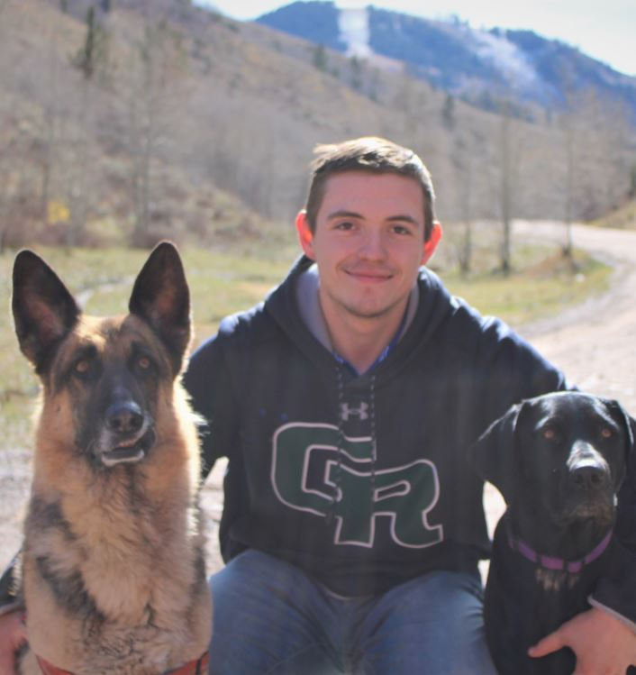

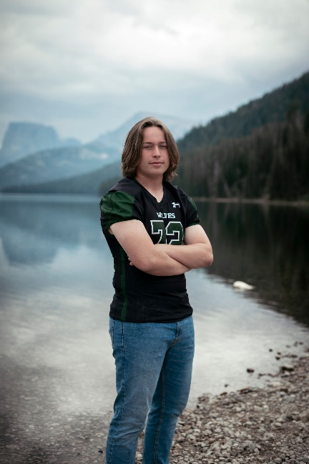

**CHRISTIAN DOBYNS**

Parents: Brent & Brandy Dobbins

GRHS

**BROOX RILEY**

Parents: Kris & Teddi Riley

GRHS

**AUSTYN MASER**

Parents: Alex & Marcie Maser

GRHS

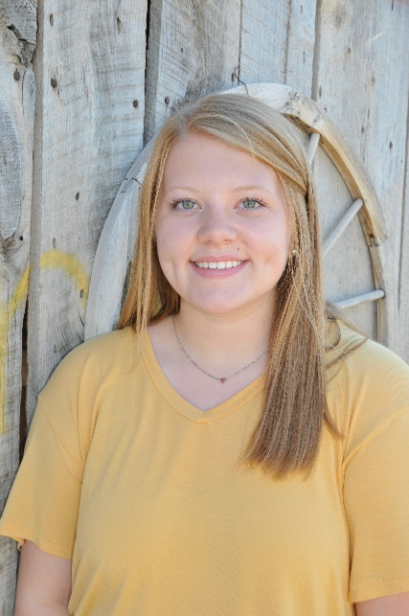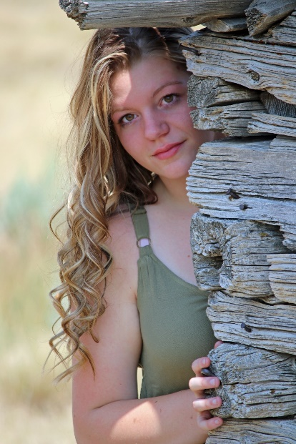

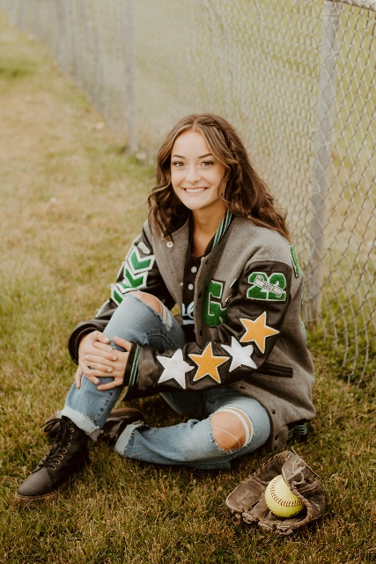

**MADISON YOAK**

Parents: Rick & Shelley Yoak

GRHS

**ADDYSON NEFF**

Parents: Scott & Marlene Neff

GRHS

**EDEN HARCOURT**

Parents: Ben & Angie Harcourt

GRHS

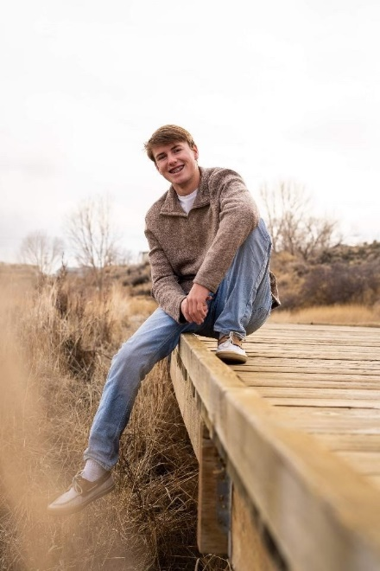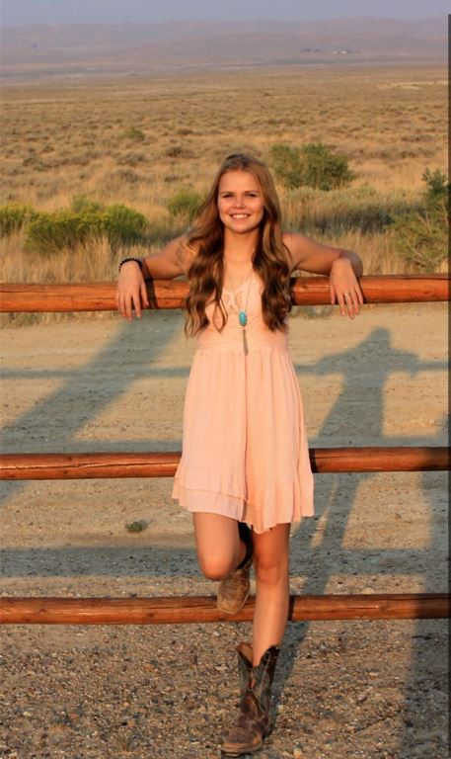

**LIBERTY JENKINS CHRISTENSEN**

Parents: Jeremiah & Trinity Christensen

RKHS

**TYREL HIGBEE**

Parents: Robert & Jamie Higbee

GRHS

**CHARLES ATKINSON**

Parents: Lewis & Willene Atkinson

RSHS



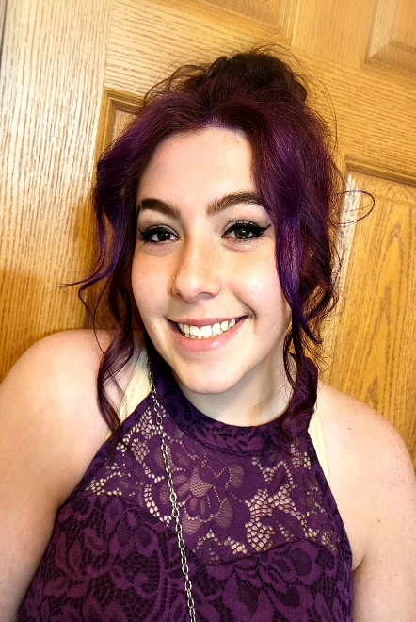

**LACIE VASQUEZ**

Parents: Jason & Brandy Clemens

RKHS

**ELYANA MENDEZ**

Parents: Rachel Evans

RKSHS

**TANNER METCALF**

Parents: Brian & Nicki Metcalf

RKHS

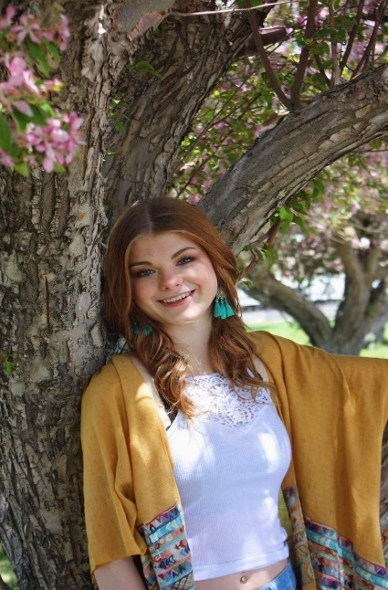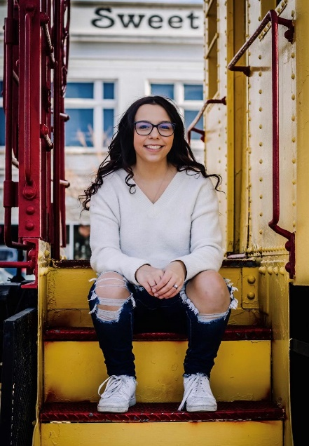

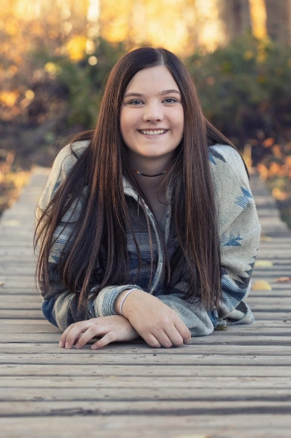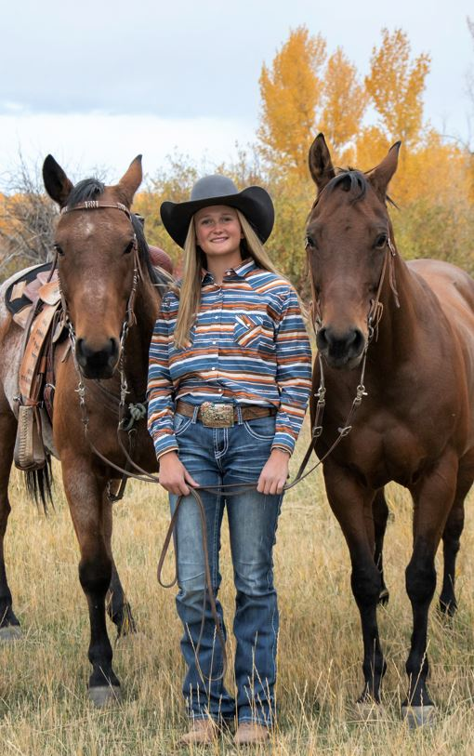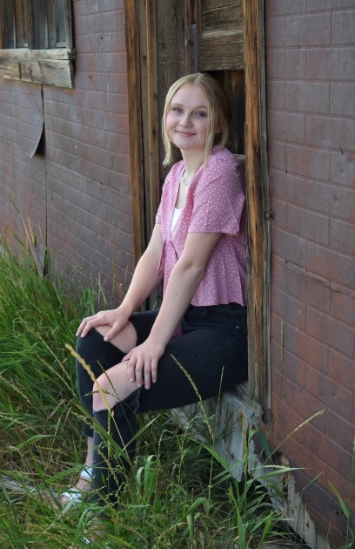

**AUTUMN JENSEN**

Parents: Scott & Meghan Jensen

& Brandy Moon

RKHS

**DAKOTA LARGENT**

Parents: John & Angie Pitts

& the late Allan Largent

MVHS

erry and Tina Fife

Murtaugh High School,

Murtaugh, Idaho

**KASSIDY HEWITT**

Parents: Rodney & Wendy Hewitt

MVHS

erry and Tina Fife

Murtaugh High School,

Murtaugh, Idaho

**JOEY LYNN SAAVEDRA**

Parents: Luis Saavedra & Bryanne Hinesley

RKHS

**JOSHUA CUSHING**

Parents: Stephen & Becky Cushing

MVHS

**BROOKE BINDL**

Parents: Curt & Ashley Bindl

MVHS

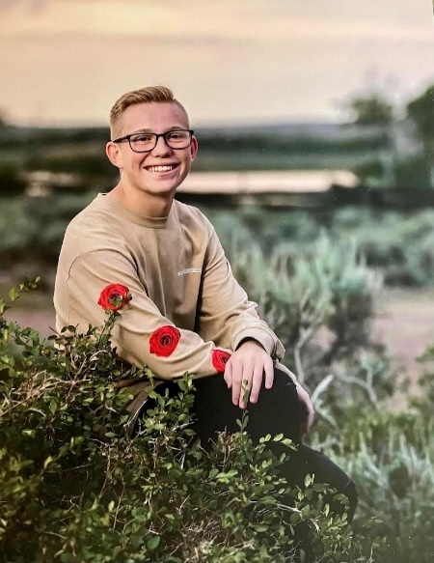

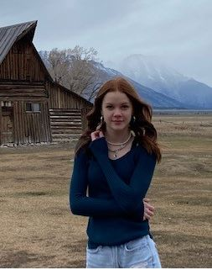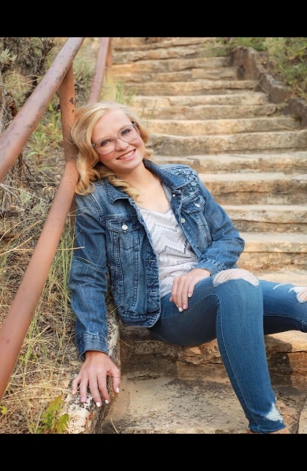

**KYLER HURDSMAN**

Parents: Ryan & Misty Hurdsman

MVHS

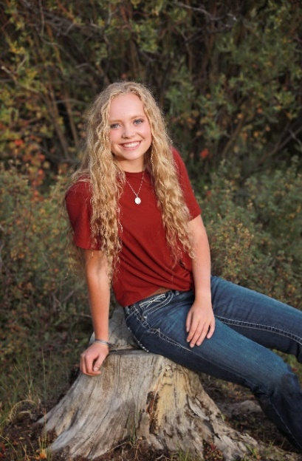

**ALYSSE CHERRINGTON**

Parents: Robert & Christina Cherrington

MVHS

**KATE WALKER**

Parents: Quinn & Chris Anne Walker

MVHS



**JAMIE STAHELI**

Parents: Travis & Lyndy Staheli

LHS

**ALYZE FARRIS**

Parents: Brandon Farris

K12

**MEGAN YOAK**

Parents: Rick & Shelley Yoak

WWCC School of Nursing

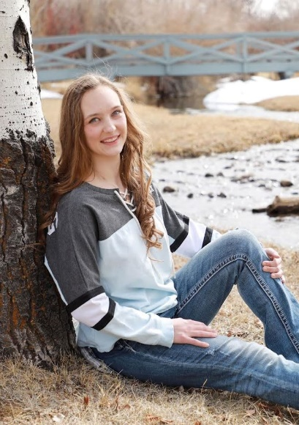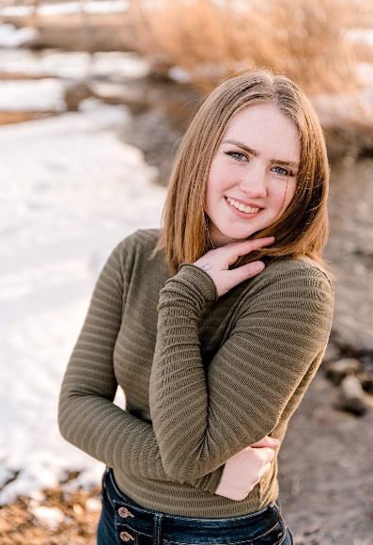

dustin

**KAYSON JAX CURTIS SNOW**

Parents: Matthew & Kaylynn Cornett

GRHS

Congratulations to the graduates of our employees and the entire class of 2022!

**GABRIELA DONAHOE**

Grand Parents: William & Becky Johnson

Connections Academy, Cody

**JILLIAN JANE BENNETT**

Parents: Bill Bennett

Hayden, CO High School

**BRITTNI WININGER**

Parents: Joe & Siara Wininger

&

Kimberly & Jace Nix

Penn Foster

**ELIZABETH ALLEN**

Parents: Tyson & Mandy Allen

Williamsburg Academy

**KATIE SETZER**

Parents: Brad Setzer

Rawlins High School